NAP8: Major complications of regional anaesthesia and other perioperative nerve injuries

Local Coordinator Guide Version 1

Content
Introduction 2
Baseline Survey 3
Individual Case Registry 4
One Year Registry Period 4
Inclusion and Exclusion Criteria 4
How to report an individual case 7
Activity Survey 8
Regulatory approvals, data security and confidentiality 9
Organising and promoting NAP8 within your department 10
Local organisation 10
Department presentation 10
Posters and flowcharts 10
Letter and email templates 11

Introduction

Thank you for agreeing to be a Local Coordinator (LC) for NAP8. You are critical to the success of this important project.

NAPs investigate serious, rare events during anaesthesia that are important to both patients and clinicians. Previous topics include complications of airway management during anaesthesia, awareness during anaesthesia, perioperative anaphylaxis and cardiac arrest. They are highly respected, supported by patients and clinicians, and have influenced the practice of anaesthesia worldwide. All local co-ordinators that have made appropriate contributions for their local site, will be credited with citable collaborator status in the main publications as part of the ‘NAP8 Collaborative Group’.

NAP8 will investigate major complications of regional anaesthesia as well as perioperative spinal cord and peripheral nerve injury. We aim to assess the incidence, current practice and outcomes of these various complications.

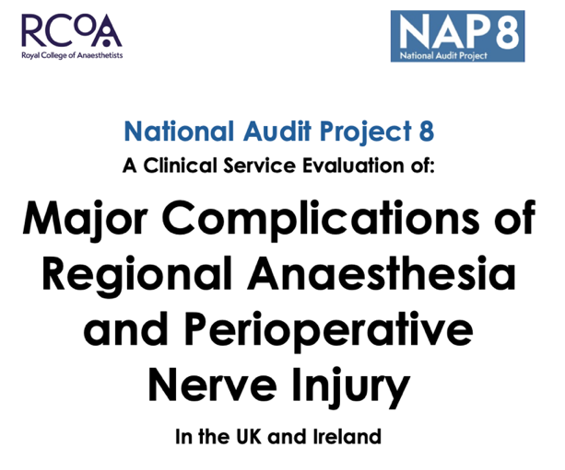

Some LCs have participated in previous NAPs and will therefore be familiar with the overall process, while others will be doing this for the first time. This guide aims to help you understand the NAP8 structure and plan locally to collect the data needed.

The structure of NAP8 will be similar to NAPs 4, 5, 6 and 7 and includes three core components, outlined below.

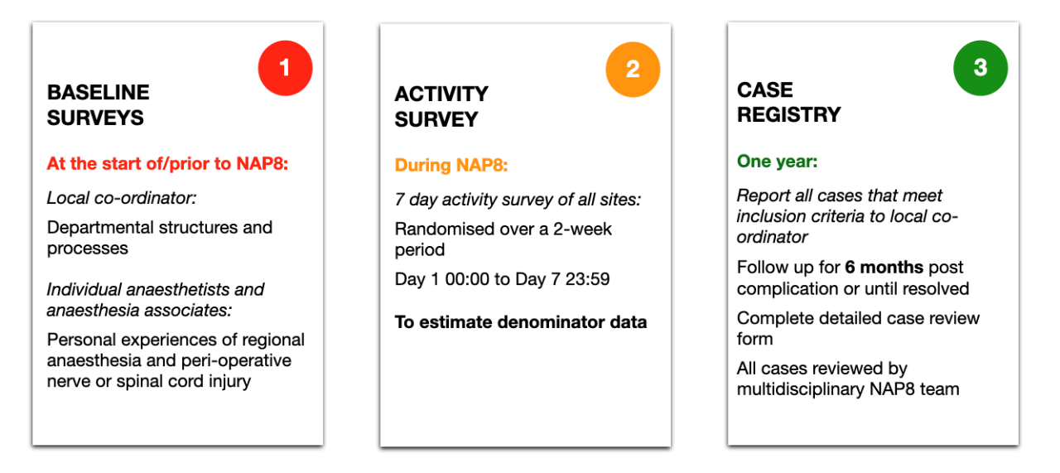

All NAP8 reporting is CONFIDENTIAL and ANONYMOUS and reviewers cannot identify the origin of any submitted report.

If you have any questions or issues at any stage, please contact us at nap@rcoa.ac.uk.

Baseline Survey

The baseline surveys will be distributed before the launch of NAP8 and there will be two components:

- Individual anaesthetist baseline survey. An online survey for all UK anaesthetists and anaesthesia associates. This will investigate attitudes, experience and training in regional anaesthesia as well as previous experience of complications of regional anaesthesia.

It will take 5-10 minutes to complete and will not require specialist knowledge.

All responses will be anonymous and confidential.

LCs will be sent a link to the online survey (TBC SurveyMonkey®). Please distribute this link to all anaesthetists and anaesthesia associates in your hospital(s).

The survey should be completed by all grades of anaesthetists and anaesthesia associates.

After completion of the survey, respondents will be asked to send an email confirming completion to their LC to enable the LC to track who in their department has responded. We appreciate that this may be an onerous task in large departments – LCs may wish to enlist the assistance of colleagues to monitor who has completed the survey so that non-responders can be reminded.

LCs will be provided with certificates that they can send to colleagues who have completed the survey.

At the end of the survey period, LCs will be asked to report how many people they sent invitations to and how many confirmed their response. This will enable the response rate to be calculated. We are aiming for a 100% response rate similar to previous NAPs which have attained high response rates.

The timeline is yet to be confirmed but LCs will receive a link for the Baseline Survey likely in late 2025. They should distribute the survey to colleagues on the dates provided or as soon as possible after this.

- Local Coordinator baseline survey. This seeks additional summary data about department size, structure, equipment and preparedness for management of regional anaesthesia complications. Patient follow up pathways, local guidelines and the availability of investigations such as MRI and electrophysiology studies and access to relevant neurosurgical or peripheral nerve surgeon expertise will also be explored.

The deadline for completion of both surveys is yet to be confirmed but is likely to be early 2026.

Individual Case Registry

The individual case reports are the central focus of NAP8 and a multidisciplinary review panel will review each complication reported.

One Year Registry Period
The case registry will provide detailed information about the occurrence, management and outcomes of all major complications of regional anaesthesia and also other cases of spinal cord and peripheral nerve injury unlikely to be directly related to the operative procedure.

Every case reported will be reviewed; most cases will undergo a more detailed review by a panel to identify key issues and themes.

You will be asked to enter into a secure online case reporting database: there will be a brief screening process followed by narrative description of the event, then a structured report detailing patient demographics, pre-operative data, intra-operative management, post-operative management and outcome of the complication. For Peripheral nerve injury (whether under regional or general anaesthesia/MAC/sedation) and also any form of spinal cord injury the outcome will be defined as permanent if still present at 6 months.

When you are made aware of any of these complications please log them into the registry at that point in time. The system will guide you through the information the multidisciplinary team would like to know in order to understand the case as best as possible. An automated email will be sent approximately 6 months after the complication date for any patient who has suffered a perioperative nerve or spinal cord injury whether secondary to regional anaesthesia or following general anaesthesia, sedation or monitored anaesthetic care. This is to seek information on all investigations and outcomes since the initial report. No specific treatment or patient contact must occur as part of NAP8. The report must simply reflect whatever standard care the patient has received as part of the follow up to the complication. The NAP8 team understand that some investigations may be outstanding or that it is not possible to answer all of the questions at the 6 month time point and ask that you complete as much as you can because after this time point no more data can be collected. The NAP8 team will use the data entered at the 6 month time point to determine if the injury is classified as permanent and also to try to determine the likelihood the nerve injury was secondary to regional anaesthesia or any other cause.

ALL CASES MUST BE REPORTED ANONYMOUSLY. PLEASE DO NOT INCLUDE ANY PATIENT, CLINICIAN OR HOSPITAL IDENTIFIERS IN ANY PART OF THE REPORT.

The date for commencement of the registry phase is yet to be confirmed but we are hoping to commence in early 2026. The case registry phase will last for ONE YEAR.

After the one year case registry period has ended the reporting system will remain open for 8 months to allow the 6 month follow up of any peripheral nerve or spinal cord injury as outlined above plus an additional 2 months to allow for the completion of data entry.

Inclusion and Exclusion Criteria
NAP8 will collect reports of all major complications of regional anaesthesia and also other cases of spinal cord and peripheral nerve injury unlikely to be directly related to the operative procedure. Detailed definitions of these complications are outlined below (also available on the NAP8 website):

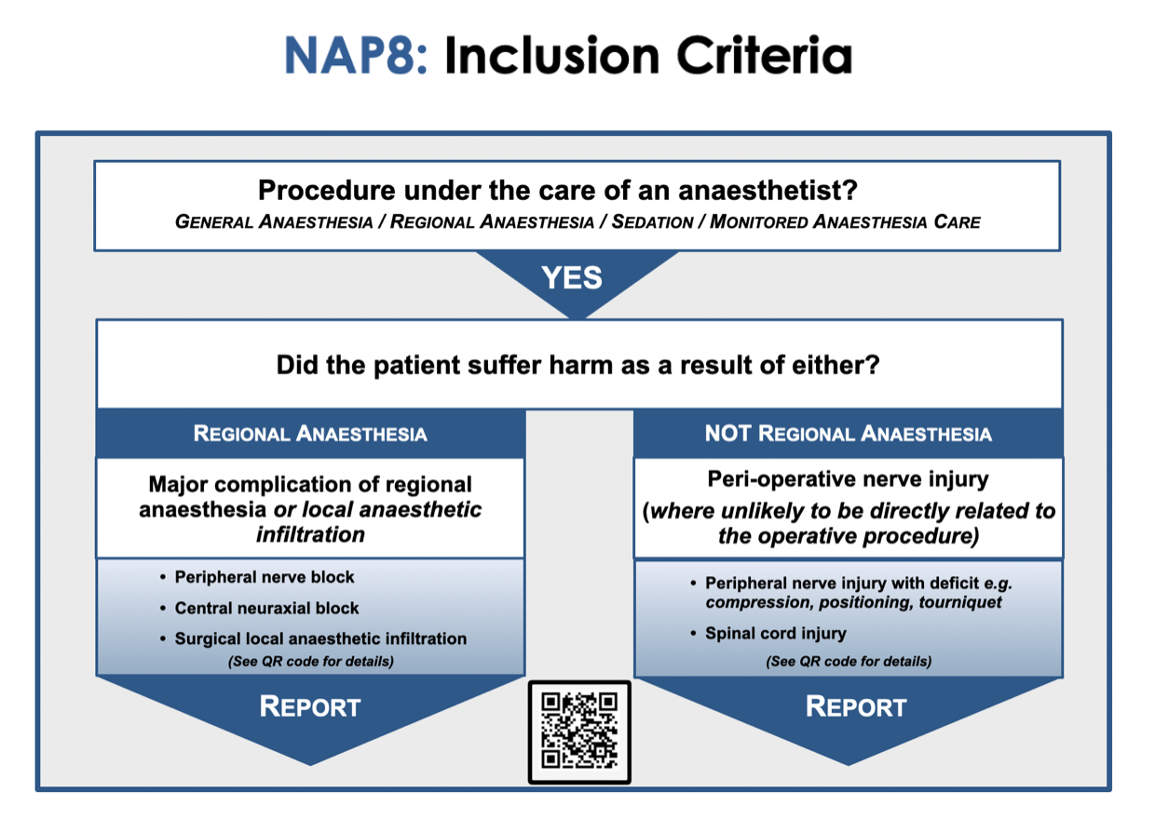

All adults and children under the care of an anaesthetist or anaesthesia associate involving general anaesthesia, regional anaesthesia or analgesia, local anaesthesia or monitored anaesthesia care (i.e. care by an anaesthetist but without administration of anaesthetic drugs) will be included. This includes cases occurring in the following clinical areas:
- All elective and emergency surgical procedures undertaken in main, trauma, day surgery and maternity (labour ward and obstetric theatres)
- All isolated sites (e.g. Electroconvulsive therapy)
- Interventional pain procedures in clinic or operating theatre
- All regional anaesthetic procedures in intensive care
- Any anaesthetic, sedation, or regional anaesthetic/analgesic procedure administered by an anaesthetist or anaesthesia associate in the Emergency Medicine department (See below)
- Any regional anaesthetic/analgesic procedure carried out by an anaesthetist or anaesthesia associate other than for the above circumstances including in intensive care or the wards e.g. rib fracture analgesia. Post-operative rescue nerve block should be treated as a separate entry.

GENERAL EXCLUSIONS
- All sedation or anaesthesia for critical care patients not involving regional anaesthesia
- All procedures on critical care except for regional anaesthetic/analgesic procedures (see above)
- Intra or interhospital transfers
- Any blocks performed by someone who is not either an anaesthetist or an anaesthesia associate

EMERGENCY DEPARTMENT
- Includes:
  - We wish to capture those patients who have had a regional block under the care of an anaesthetist or anaesthesia associate in the emergency department. Any regional block undertaken by an emergency department physician should NOT be included. There is a separate project planned with the Royal College of Emergency Medicine exploring the use of regional anaesthesia by Emergency Physicians in the Emergency Department.

All exclusions do not apply if the patient has already met, or later meets, inclusion criteria.

For complications listed below that occur during the registry phase secondary to regional anaesthesia or surgical local infiltration:
- The patient must be under the care of an anaesthetist or anaesthesia associate at the time of the index procedure.
- The complication must be related to one or more of either a central neuraxial block (epidural, caudal, spinal or CSE), a peripheral nerve block or surgical local infiltration (including surgically placed local anaesthetic wound catheters)
  - This includes attempted central neuraxial or peripheral nerve blocks that were abandoned for whatever reason
  - This includes complications related to removal of any central neuraxial or peripheral nerve catheter
- Unless otherwise stated in the exclusion criteria please report all complications listed below irrespective of the level of harm that occurred to the patient. The NAP8 team will classify level of harm using the information provided during the case registry report.
- Precise time frames have deliberately not been included for most complications to encourage reporting. Whilst some complications present immediately, others can be delayed. For many of the complications listed below reports exist of delayed presentation by up to several weeks or longer.
  - If the complication occurs or presents during the case registry phase but the original procedure occurred before the start of the case registry phase, PLEASE REPORT.
  - If the procedure takes place during the registry phase but the complication occurs or presents after the end of the case registry phase, DO NOT report.
- If in any doubt report

Complication | Inclusion criteria | Exclusion criteria | Comments
Either CNB or PNB

Wrong route drug error | Intravascular administration of a medication that was intended for perineural, intrathecal or epidural administration  OR  Perineural, intrathecal or epidural administration of a medication that was intended to be administered by another route |  | NHS Never Event therefore report irrespective of whether physical or psychological harm was incurred
Local anaesthetic systemic toxicity (LAST) | Administration of local anaesthetic by a surgeon for anaesthesia/analgesia AND/OR administration of local anaesthetic by an anaesthetist, by bolus or infusion for regional anaesthesia/analgesia  AND EITHER  Clinical features of moderate to severe LAST e.g. seizure, loss of consciousness, cardiac arrhythmia* or cardiac arrest  OR  Administration of lipid emulsion therapy | Possible local anaesthetic toxicity which did not meet a threshold of at least moderate harm (for example patient report of circumoral tingling, tinnitus)  LAST secondary to sole use of intravenous lidocaine for pain procedures or peri-operative analgesia (i.e. not in conjunction with central neuraxial block, peripheral nerve block or surgical local infiltration)  Topicalisation of airway for awake tracheal intubation where no airway nerve blocks have been performed | * Cardiac arrythmia requiring unplanned monitoring, haemodynamic instability, and/or active intervention
Pneumothorax | New presence of air in the pleural cavity confirmed on radiological investigation | Pneumothorax arising as an expected outcome following surgery (for example thoracic surgery) concurrent with central neuraxial or peripheral nerve blockade
Cardiac arrest directly due to regional anaesthesia | Five or more chest compressions or use of defibrillation.  OR  Withdrawal of care during procedure or in recovery  OR  Died during anaesthesia care or in recovery | Cardiac arrest, withdrawal of care or died during procedure or treatment but cause not directly related to regional anaesthesia
Infection at site of regional anaesthesia | Infection occurring within 30 days at or near the site of a previous peripheral nerve or central neuraxial block, either single shot or catheter, leading to localised abscess, discitis, osteomyelitis, systemic infection, or necrotising fasciitis  AND  Required antibiotic therapy  AND EITHER  Positive contributory micro-organism culture taken from either blood, abscess, or site swab  OR  Imaging or clinical suspicion consistent with infection due to the central neuraxial or peripheral nerve block | Insertion site inflammation or localised cellulitis  OR  Catheter or insertion site colonisation (culture-positive perineural or epidural catheters but with no clinical evidence of site infection or requirement for antibiotic therapy)  OR  Vertebral canal abscess and infective meningitis (reported separately)
Anaphylaxis | Life-threatening anaphylaxis* confirmed to be secondary to local anaesthetic, another drug mixed with the local anaesthetic administered during the central neuraxial or peripheral nerve block, or to skin preparation solutions for block performance** | Anaphylaxis confirmed by allergen testing to be secondary to any drug used for sedation or general anaesthesia in a patient who had a concurrent central neuraxial or peripheral nerve block | *Unexpected severe hypotension  AND/OR  Severe bronchospasm  AND/OR  Swelling with actual or potential airway compromise  OR  Cardiac arrest  **Please log the anaphylaxis in the NAP8 case registry at the time of presentation. An automatic alert will be sent at 6 months to please review the patient case notes, log in and follow instructions to record if anaphylaxis has been confirmed as being secondary to any components of the regional anaesthesia technique.
Visceral or other organ injury | Inadvertent traumatic needling injury to a visceral or other organ, whether recognised at the time or afterwards | Vascular, neurological or pleural injury are separate complications and should be reported elsewhere | Examples include liver capsule penetration leading to haematoma during transverse abdominis plane (TAP) blockade, bowel perforation during abdominal wall block, globe perforation during peribulbar blockade
CNB

High/total/complete spinal | Any patient who develops a high block in association with central neuraxial anaesthesia/analgesia which is associated with requirement for ventilatory support* or cardiopulmonary resuscitation**  OR  Any patient who develops a high block from epidural or intrathecal spread of local anaesthetic following a peripheral nerve block |  | * Ventilatory support includes the additional use of ‘bag/mask’ ventilation, or ventilation assisted by the use of a supraglottic airway device or endotracheal tube  **Cardiopulmonary resuscitation includes the use of basic and advanced life support
Respiratory failure | Any patient who develops respiratory failure due to neuraxial opioids which is associated with requirement for ventilatory support* | Respiratory failure secondary to high/total/complete spinal should be reported elsewhere  Patients requiring supplemental oxygen or naloxone | * Ventilatory support includes the additional use of ‘bag/mask’ ventilation, or ventilation assisted by the use of a supraglottic airway device or endotracheal tube
Vertebral canal haematoma | Confirmed new inadvertent accumulation of blood in the extra-cranial intramedullary, subdural or epidural space | Purposeful injection of blood into the epidural space performed as part of dural blood patching  OR  Vertebral canal haematoma presenting after spinal or neurological surgery and thought to have arisen as a surgical complication
Vertebral canal abscess | Confirmed new infection within the extra-cranial intramedullary, subdural or epidural space | Vertebral canal abscess presenting after spinal or neurological surgery and thought to have arisen as a surgical complication rather than from regional anaesthesia
Infective meningitis | Clinical or laboratory diagnosis of infective bacterial or viral meningitis | Infective meningitis presenting after spinal or neurological surgery
Adhesive arachnoiditis | Arachnoid inflammation, intrathecal scars and dural adhesions, identified on radiological imaging
Nerve injury after central neuraxial block | Spinal cord ischaemia or infarction  OR  Direct spinal cord injury  OR  Direct radicular or other non-cord nerve injury
‘Other’ complication not listed above | Radiologically confirmed intracranial infarction or haemorrhage occurring after CNB (including but not limited to: Subdural haematoma, subarachnoid haemorrhage, intraventricular haemorrhage, cerebral venous sinus thrombosis or pituitary apoplexy)  OR  Radiologically confirmed Posterior Reversible Encephalopathy Syndrome (PRES)  OR  Cranial nerve palsy, where intracranial haemorrhage or space occupying lesion has been excluded on radiological imaging  OR  Any other complication secondary to central neuraxial block not listed above | Accidental dural puncture with or without epidural blood patch which does not result in any of the listed complications
Peripheral nerve blocks

Wrong site block | A nerve block performed on the wrong patient or the wrong site, whether local anaesthetic was injected or not |  | Never event therefore report irrespective of whether physical or psychological harm was incurred
Phrenic nerve palsy | Unplanned requirement for non-invasive or invasive ventilation  OR  Confirmed unilateral diaphragmatic weakness causing functional impairment more than 48 hours after either a single shot block or removal of a nerve catheter | The need for supplemental oxygen, but no requirement for non-invasive or invasive ventilation after regional anaesthesia
Haemorrhage | Haemorrhage arising from a regional anaesthetic procedure  AND EITHER  Required treatment with blood products  OR  surgery  OR  interventional radiological intervention | Haemorrhage which requires observation or conservative management only (including manual pressure)
Peripheral nerve injury following peripheral nerve block | Unintended new abnormality in one or more modalities (sensory, motor, pain or autonomic) lasting more than 48 hours after either a single shot block or removal of a nerve catheter* | Cause, agreed by local multidisciplinary clinical team to be secondary to direct surgical injury. If in doubt report | Abnormalities do not need to map to any particular nerve or radicular distribution  Neurological abnormality may be a change of function in any specific modality (e.g. in the sensory modality both unintended new loss of sensation and new paraesthesia should trigger reporting)  *If a patient presents with a suspected nerve injury please log the nerve injury in the NAP8 database at the time of presentation. An automatic alert will be sent at 6 months to please review the patient case notes, log in and follow instructions. This information will be vital and will be used by the multidisciplinary review team to a) determine causality and b) to define the injury as permanent or not
‘Other’ complication not listed above | Any other complication secondary to peripheral nerve block not listed anywhere above

For complications listed below that occur during the registry phase that were NOT secondary to regional anaesthesia or surgical local infiltration:
- The patient must be under the care of an anaesthetist or anaesthesia associate at the time of the index procedure.
- If the patient has had either a central neuraxial block (epidural, caudal, spinal) or a peripheral nerve block, do NOT report here but please see the relevant regional anaesthesia definitions above and if appropriate report in the relevant section of the case registry
- Unless otherwise stated in the exclusion criteria please report all complications listed below irrespective of the level of harm that occurred to the patient. The NAP8 team will classify level of harm using the information provided during the case registry report.
- Precise time frames have deliberately not been included to encourage reporting. Whilst some complications present immediately, others can be delayed.
  - If the complication occurs or presents during the case registry phase but the original procedure occurred before the start of the case registry phase, PLEASE REPORT.
  - If the procedure takes place during the registry phase but the complication occurs or presents after the end of the case registry phase, DO NOT report.
- If in any doubt report

Complication | Inclusion criteria | Exclusion criteria | Comments
Spinal cord injury (general anaesthesia /sedation/MAC) | Clinical signs and/or symptoms consistent with unintended or unexpected, new spinal cord injury at any level whether temporary or permanent  AND  Supported by radiological and/or neurophysiological investigations and/or clinical intervention e.g. surgical decompression, evacuation of haematoma, spinal drain based on clinical judgement | Injury directly related to surgical manipulation during spinal surgery  OR  Any injury consistent with direct surgical cord injury  OR  Any isolated intracranial cause which explains symptoms/signs  OR  Any case where preoperative neurological status could not be reliably assessed, making confirmation of a new injury following anaesthesia uncertain e.g. patient required intubation of the trachea by pre-hospital team  OR  Cause agreed by local multidisciplinary team, to be secondary to central neuraxial block (report under CNB complications) | Cases involving cross clamping of major vessels, cardiac surgery or endovascular work are to be included
Peripheral nerve injury  (general anaesthesia /sedation/MAC) | Unintended new abnormality in one or more modalities (sensory, motor, pain or autonomic) lasting more than 48 hours following the end of the procedure* | Cause agreed by local multidisciplinary team to be secondary to direct surgical injury. If unsure report.  OR  Nerve injury secondary to airway manipulation e.g. lingual or hypoglossal nerves secondary to laryngeal mask positioning  OR  Critical illness polyneuropathy following surgery and ICU stay | For example brachial plexus injury following Trendelenburg position; common peroneal nerve injury following lithotomy position; ulnar nerve injury due to compression; tourniquet related injury  Abnormalities do not need to map to any particular nerve or radicular distribution.  Neurological abnormality may be a change of function in any specific modality (e.g. in the sensory modality both unintended new loss of sensation and new paraesthesia should trigger reporting)  *Please follow standard care pathways including referral to neurological/surgical services, imaging and nerve conduction studies where deemed appropriate by local team. Please log the nerve injury in the NAP8 database at the time of presentation. An automatic alert will be sent at 6 months to please review the patient case notes, log in and follow instructions. This information will be vital and will be used by the multidisciplinary review team to a) determine causality and b) to define the injury as permanent or not

How to report an individual case
Cases should be reported as soon as possible after a complication has occurred. This will ensure any details relying on recall are as accurate and complete as possible. The following cases below will also trigger a follow up email at 6 months:

- General anaesthesia/MAC/sedation
  - Peripheral nerve injury
  - Spinal cord injury
- Regional anaesthesia
  - Central neuraxial blocks
    - Vertebral canal haematoma
    - Vertebral canal abscess
    - Nerve injury after central neuraxial block
  - Peripheral nerve block
    - Peripheral nerve injury

This will allow the NAP8 team to classify if the injury is permanent or not.

All reports will be anonymous and confidential.

All major complications of regional anaesthesia or other case of spinal cord and peripheral nerve injury fulfilling the inclusion criteria should be reported to NAP8 if anaesthesia care started between 00:00:00 hrs on xx (TBC) and 23:59:59 hrs on xx (TBC).

If the LC becomes aware of a major complication of regional anaesthesia or other case of spinal cord and peripheral nerve injury in their hospital(s), the following steps should be taken:

- Liaise with the anaesthetist(s) involved if they have not already contacted you.
- Contact NAP8 (nap@rcoa.ac.uk) who will issue you a secure login specific for the case on the database.
- Retrieve anaesthetic and other relevant case notes.
- Whilst logged into the database, extract the information needed in the structured case review. It is expected that you will need to discuss the case in detail with the anaesthetist(s) involved. It may be that you and the anaesthetist involved in the case will need to work together to enter the data.

A step-by-step guide to reporting the case will be attached to the login details and available on the Local Coordinator resources page of the website.

Monthly reminders
LCs will be contacted monthly to check if there have been any cases in their hospital. As in previous NAPs, please report this value monthly, even when there are no major complications of regional anaesthesia or other cases of spinal cord and peripheral nerve injury at your site.

As the inclusion criteria extend beyond the anaesthetic department, we request that LCs formally check with the following sources for potentially eligible cases:
- Surgical clinical directors
- Physiotherapists
- Neurologists
- Radiologists
- Electrophysiologists
- Clinical governance and medicolegal teams
Further information and supporting material is provided to help with this (see later).

Activity Survey

The activity survey will be carried out during the 12-month registry period (likely beginning in June 2026). It will serve two purposes:

- Create a quantitative snapshot of anaesthetic activity in the UK.
This will be used to calculate denominator data for NAP8 and will be compared to previous NAP activity surveys to show how anaesthetic practice in the UK is evolving.

- Collect details pertinent to regional anaesthesia, regional anaesthesia complications and spinal cord and perioperative nerve injury.
This will help develop a more detailed understanding of regional anesthesia practice across the UK as well as collecting specific patient, surgical and procedural risk factors that are relevant to the complications collected during the registry phase.

Each hospital site will be asked to survey on seven consecutive days (TBC). The specific seven days for each site will be randomly allocated (except for specialist hospitals which will have a different allocation process) to one of two weeks (TBC). LCs will be asked to facilitate this survey in their hospital to ensure that all anaesthetists are aware of the survey and to check that all patients have a completed survey form.

As in previous NAPs, one activity survey entry will be completed by the anaesthetist or anaesthesia associate for each interventional procedure during the survey period at each site (general anaesthesia, regional anaesthesia, sedation or managed anaesthesia care).

The activity survey will be completed electronically via SurveyMonkey®(TBC). A link will be sent to the survey and each case will be recorded by completing the survey. We strongly advise that individual anaesthetists complete the link themselves as soon after the case as practically possible. This process should be aided by the LC and other assistants over the activity survey period to ensure all cases are captured. There will need to be oversight to ensure out-of-hours cases and remote site cases are captured. As all clinical areas covered by the case registry phase of NAP8 need to be covered by the activity survey, relevant remote sites need to be included – for example, the emergency department, obstetrics, radiology and the ECT suite.

The NAP8 team will liaise with LCs to ascertain how many of the cases undertaken on those seven days were successfully captured. The target case ascertainment is 100%.

More details about the activity survey will be distributed to you when the dates for your site(s) are assigned.

Regulatory approvals, data security and confidentiality
The NAPs are clinical service evaluations, rather than research, using strict criteria set by the Health Research Authority (HRA). This is because there is no intervention, no randomisation of patients and no change to normal patient care or treatment. The project is simply observing current practice. Therefore, the project does not require research ethics committee approval, in line with the HRA’s decision tools (The National Research Ethics Service (NRES) Defining Research table and the algorithm ‘Does my project require review by a Research Ethics Committee?’). This has also been confirmed by review of the protocol and discussions with the chair of the West of Scotland Research and Ethics Committee.
On a local level Caldicott guardian approval will be required for each site in England, Scotland and Wales. We will seek assistance from each LC in identifying the Caldicott guardian in each trust/health board but the NAP8 team will make the application on your behalf. Discussions with the Information Governance lead of the Department of Health in Northern Ireland are underway. We hope thereafter this will result in approval for all trusts in Northerin Ireland to take part.
Ireland are taking part in NAP8 and we are currently seeking approval from the the National Centre for Clinical Audit.
All members of the NAP8 panel have undergone information governance training in line with these regulatory bodies.
As for NAPs 3-7, NAP8 will seek endorsement from all four Chief Medical Officers of the United Kingdom (xxx; xx 2025).
Case registry data will be uploaded via a secure web-based tool using SSL encryption onto the Royal College of Anaesthetists (RCoA) servers with high-grade anomaly and intrusion detection, and firewalls in operation.
Baseline and Activity Surveys
All individual survey returns will be confidential and will contain no clinician or patient identifiers. Hospital location for baseline and activity surveys will be included only to enable management of the project (to identify whom to send reminders to) and will be removed before analysis. All data used for publication or presentation will be fully anonymous.

Review of Cases
Only members of the NAP8 review panel with authorisation from the NAP8 Clinical Lead (AJRM) and Chair of the RCoA Centre for Research and Improvement (IM) will have access to the data.
No panel member, including the Clinical Lead and Chair of the RCoA Centre for Research and Improvement, will have access to the location or identity of the reporters, clinicians or patients at any stage of the project. It will not be possible to trace any data back to the reporter, clinicians or patients later.
When the review panel assesses cases, data will be provided for review only. Review panel members are not permitted to discuss the details of cases outside of the review meetings. Further, if they feel they can connect the case they are reviewing with knowledge from outside the review process they are not permitted to share this. This will ensure that the review process is not biased by prior knowledge, and prevent possible identification of the reporters, clinicians or patients involved.

Organising and promoting NAP8 within your department
We aim to make the LC role as straightforward as possible and will supply electronic resources to help local organisation and promotion of the project. These will be available on the NAP8 website and you can customise them with your contact details as needed.

Local organisation
As LC, we are very grateful to you for ensuring that everyone at your site is aware of their roles within NAP8 at various stages of the project. As the LC in a small unit, the workload will likely be manageable. However, at larger sites, it may be more challenging, and we suggest forming a local network. It is important to have contacts in areas you do not commonly work in. For example, if you are a general anaesthetist with separate obstetric, paediatric and pain anaesthetists for example, it would be good to identify one or more link persons. These persons can help identify cases in their area and clarify sub-specialty specific aspects of the case registry form.
Before the launch of the project, LCs should complete the following checklist:
- Review all NAP8 materials and contact the NAP8 team with any questions at nap@rcoa.ac.uk.
- Try to present at one or more departmental meetings and provide an overview of the project (e.g. audit, M&M, consultant meeting, trainee teaching). PowerPoint slides for this are available here.
- Try to attend a NAP8 webinar with Q&A session, hosted by the NAP8 team. If you are unable to attend, the recordings will be made available on the NAP8 website.
Consider the best way to identify events that occur following the end of a patient’s procedure. Whilst some of the complications will present at the time of surgery some will not always present at the time of the original hospital admission e.g. peripheral nerve injury. Patients may present post-operatively to surgeons, neurologists, physiotherapists, the acute pain team or other healthcare professionals. Some may even present via the medicolegal department. A list of such professionals is listed below and on the NAP8 resources page and we ask that contact is made with each relevant local healthcare provider or team in your hospital to alert them about NAP8 and ask them to highlight any relevant patients to you the local co-ordinator. This will help with post-operative event capturing. Sample emails can be found on the NAP8 resources page.
- Surgical clinical directors
- Physiotherapists
- Acute pain teams
- Neurologists
- Radiologists
- Electrophysiologists
- Clinical governance leads and medicolegal teams

Department presentation
We suggest that LCs aim to promote the NAP8 project locally with the help of a pre-populated PowerPoint presentation that can be downloaded from the NAP8 website (this will be available soon).

Posters and flowcharts
These will be provided to assist in advertising the project within your hospital, and to increase engagement and awareness amongst the perioperative team. Example locations to display these include anaesthetic departments, all post-operative areas and surgical wards, intensive care units, neurology and neurosurgical departments, physiotherapy departments etc. Posters can be found on the NAP8 website and printed locally.

Letter and email templates
1. For anaesthetic and intensive care consultants, resident doctors, SAS doctors and anaesthesia associates.
2. All relevant medical and allied healthcare staff within the hospital as above.
The NAP8 team have provided suggested templates on the NAP8 website.

If you have any further questions please contact nap@rcoa.ac.uk. An FAQs document can be found on the NAP8 website and will be updated regularly as needed.

Prof Alan Macfarlane Prof Iain Moppett
Clinical Lead for NAP8 Chair of the RCoA Centre for Research and Improvement

